**Clamper Circuit**

**Lab No#06**



**Spring 2021**

**CSE-206L Electronic Circuits Lab**

Submitted by: **Ashfaq Ahmad**

Registration No: **19PWCSE1795**

Class Section: **B**

“On my honor, as student of University of Engineering and Technology, I have neither given nor received unauthorized assistance on this academic work.”

Student Signature: ______________

Submitted to:

**Eng: Abdullah Hameed**

June 14, 2021

**Department of Computer Systems Engineering**

**University of Engineering and Technology, Peshawar**

### Objectives:

* To become familiar with the function and operation of clamper Circuits.

**Equipment:**

* Ac voltage Source
* DC voltage Source

**Components**

* Diode: Silicon (D1N4002)
* Resistors: 100kΩ
* Capacitor: 1 µF

## Theory:

**Diode:**

A diode is a two-terminal electronic component that conducts current primarily in one direction; it has low resistance in one direction, and high resistance in the other.

## Clamper definition

* A clamper is an electronic circuit that changes the DC level of a signal to the desired level without changing the shape of the applied signal.
* In other words, the clamper circuit moves the whole signal up or down to set either the positive peak or negative peak of the signal at the desired level.
* The Clamper Circuit simply adds or Subtract dc component to the input signal.
* A clamper circuit adds the positive dc component to the input signal to push it to the positive side.
* Similarly, a clamper circuit adds the negative dc component to the input signal to push it to the negative side.
* The construction of the clamper circuit is almost similar to the clipper circuit.
* The only difference is the clamper circuit contains an extra element called capacitor.  A capacitor is used to provide a dc offset (dc level) from the stored charge.
* A typical clamper is made up of a capacitor, diode and resistor.
* Some clampers contain an extra element called DC battery. The resistors and capacitors are used in the clamper circuit to maintain an altered DC level at the clamper output.
* The clamper is also referred to as a DC restorer, clamped capacitors, or AC signal level shifter.

## Types of clampers

Clamper circuits are of three types:

* Positive clampers
* Negative clampers
* Biased clampers

## Positive clamper

* If the circuit pushes the signal upwards then the circuit is said to be a positive clamper.
* When the signal is pushed upwards, the negative peak of the signal meets the zero level.
* Positive clamper adds the positive dc component to the input signal to push it to the positive side.

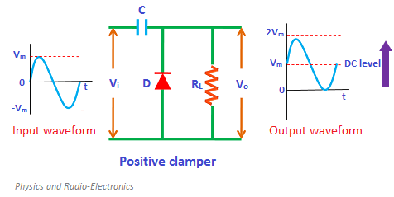

**Construction and Function of Positive Clamper:**

The positive clamper is made up of a voltage source Vi, capacitor C, diode D, and load resistor RL. In the below circuit diagram, the diode is connected in parallel with the output load. So the positive clamper passes the input signal to the output load when the diode is reverse Biased and blocks the input signal when the diode is Forward Biased.

**During negative half cycle:**

During the negative half cycle of the input AC signal, the diode is forward biased and hence no signal appears at the output. In forward biased condition, the diode allows electric current through it. This current will flows to the capacitor and charges it to the peak value of input voltage Vm. The capacitor charged in inverse polarity (positive) with the input voltage. As input current or voltage decreases after attaining its maximum value -Vm, the capacitor holds the charge until the diode remains forward biased.

**During positive half cycle:**

During the positive half cycle of the input AC signal, the diode is reverse biased and hence the signal appears at the output. In reverse biased condition, the diode does not allow electric circuit through it. So the input current directly flows towards the output.

When the positive half cycle begins, the diode is in the non-conducting state and the charge stored in the capacitor is discharged (released). Therefore, the voltage appeared at the output is equal to the sum of the voltage stored in the capacitor (Vm) and the input voltage (Vm) { I.e. Vo = Vm+ Vm= 2Vm}which have the same polarity with each other. As a result, the signal shifted upwards.

The peak to peak amplitude of the input signal is 2Vm, similarly the peak to peak amplitude of the output signal is also 2Vm. Therefore, the total swing of the output is same as the total swing of the input.

The basic difference between the clipper and clamper is that the clipper removes the unwanted portion of the input signal whereas the clamper shift the input signal upwards or downwards.

**Proteus Schematic:**

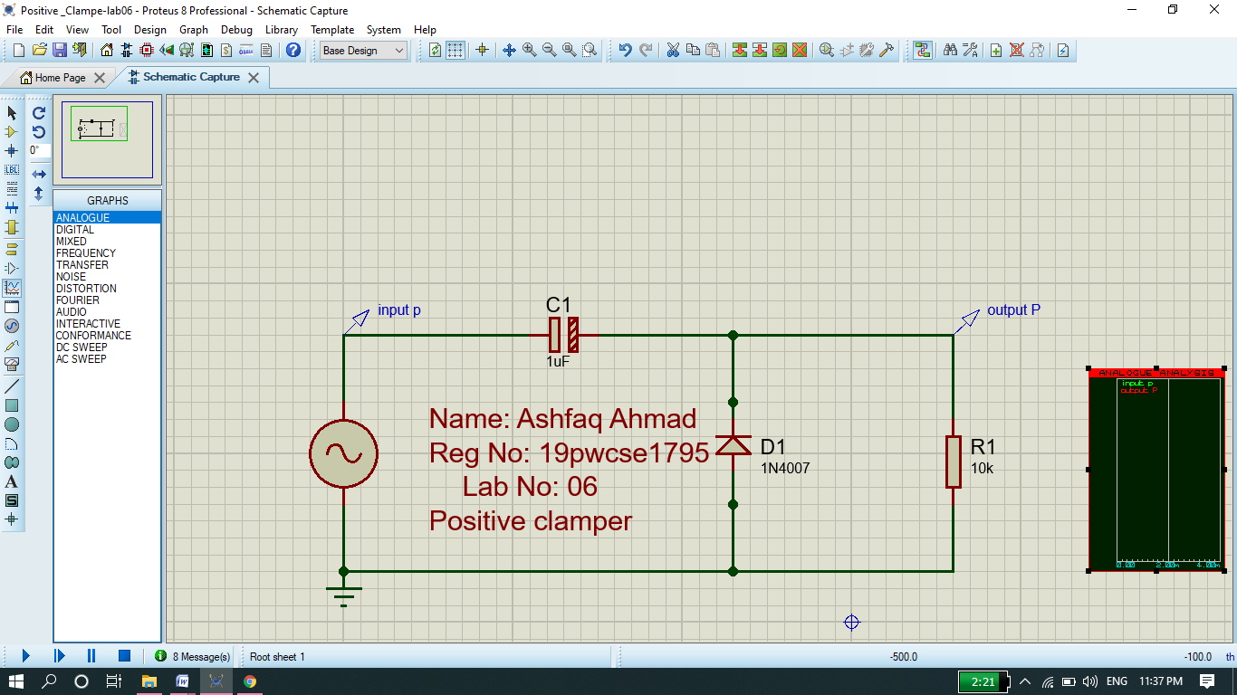

**Output Signal:**

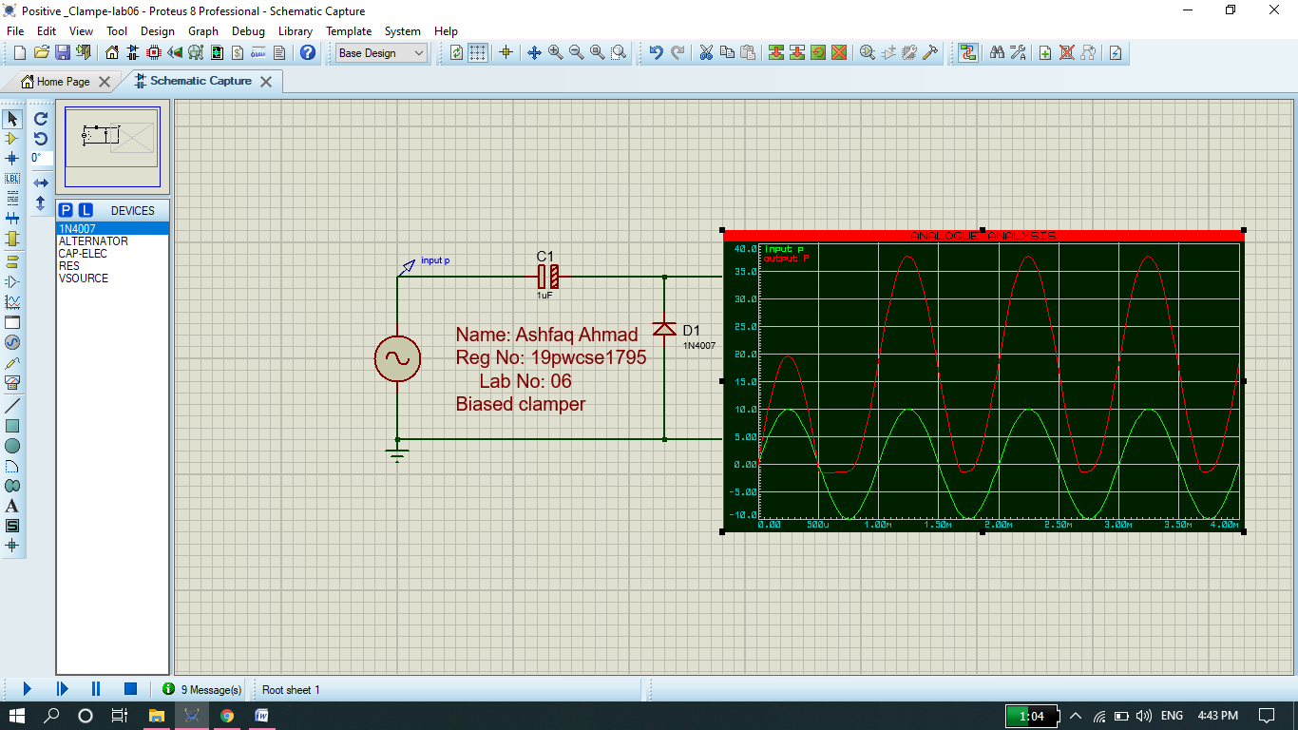

## Negative clamper

* If the circuit pushes the signal downwards then the circuit is said to be a negative clamper.
* When the signal is pushed downwards, the positive peak of the signal meets the zero level.
* A negative clamper circuit adds the negative dc component to the input signal to push it to the negative side.

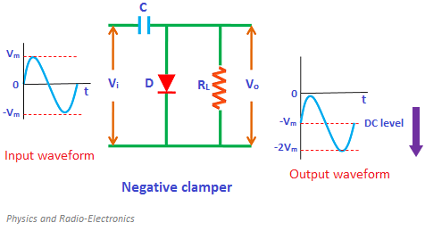

**Function of Positive Clamper:**

**During positive half cycle:**

During the positive half cycle of the input AC signal, the diode is forward biased and hence no signal appears at the output. In forward biased condition, the diode allows electric current through it. This current will flows to the capacitor and charges it to the peak value of input voltage in inverse polarity -Vm. As input current or voltage decreases after attaining its maximum value Vm, the capacitor holds the charge until the diode remains forward biased.

**During negative half cycle:**

During the negative half cycle of the input AC signal, the diode is reverse biased and hence the signal appears at the output. In reverse biased condition, the diode does not allow electric current through it. So the input current directly flows towards the output.

When the negative half cycle begins, the diode is in the non-conducting state and the charge stored in the capacitor is discharged (released). Therefore, the voltage appeared at the output is equal to the sum of the voltage stored in the capacitor (-Vm) and the input voltage (-Vm) {I.e. Vo = -Vm- Vm= -2Vm}which have the same polarity with each other. As a result, the signal shifted downwards.

**Proteus Schematic:**

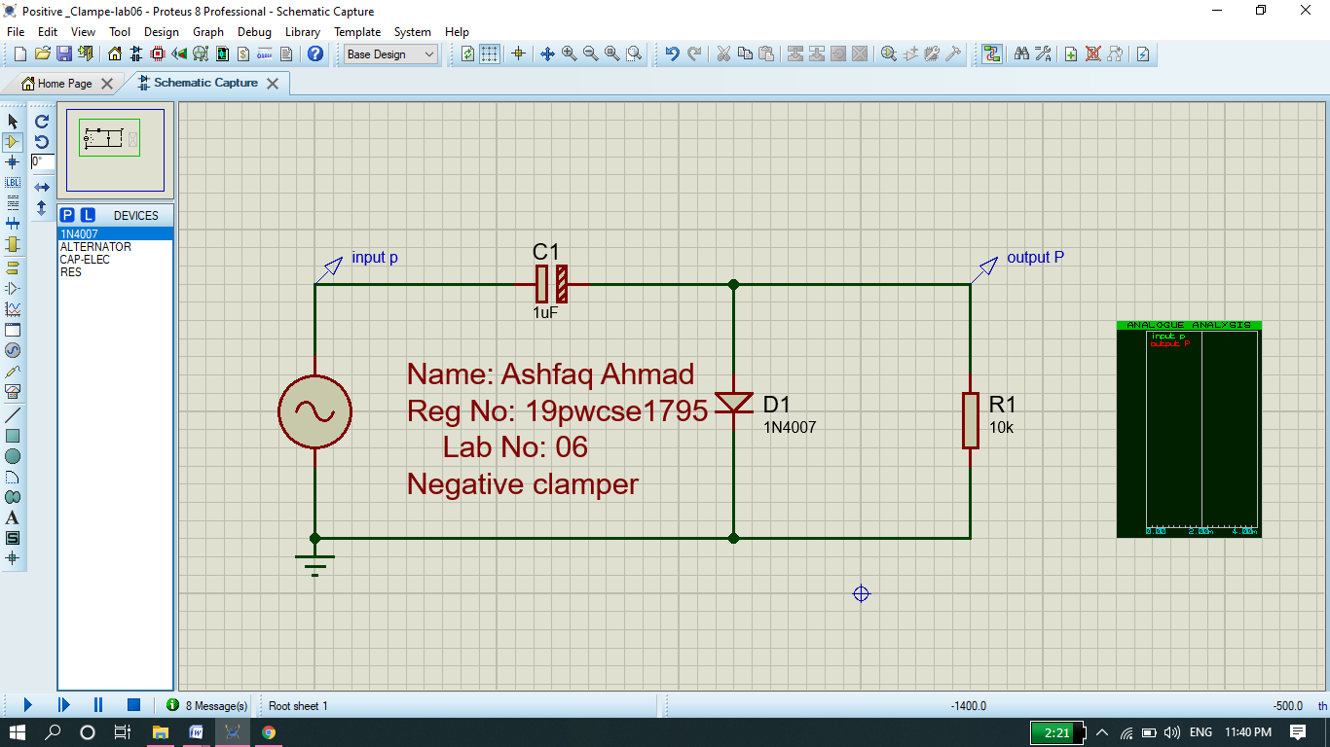

**Graph:**

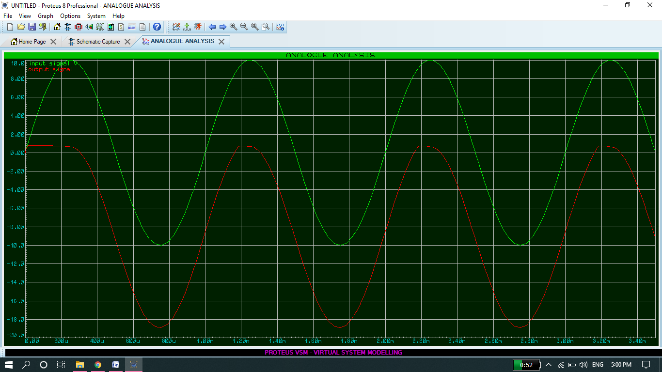

## Biased clampers

* Sometimes an additional shift of DC level is needed.
* In such cases, biased clampers are used.
* The working principle of the biased clampers is almost similar to the unbiased clampers.
* The only difference is an extra element called DC battery is introduced in biased clampers.

**Types of Biased Clamper**

**Four types of biased clamper.**

### Positive clamper with positive bias:

* If positive biasing is applied to the clamper then it is said to be a positive clamper with positive bias.
* The positive clamper with positive bias is made up of an AC voltage source, capacitor, diode, resistor, and dc battery.

The circuit diagram is shown below.

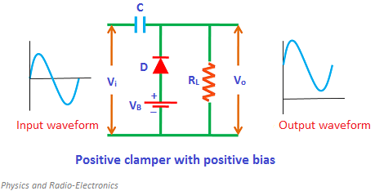

**During positive half cycle:**

During the positive half cycle, the battery voltage forward biases the diode when the input supply voltage is less than the battery voltage. This current or voltage will flows to the capacitor and charges it.

When the input supply voltage becomes greater than the battery voltage then the diode stops allowing electric current through it because the diode becomes reverse biased. So Vout=vin+vc (here capacitor charged more due vdc so some more extra shift).

**During negative half cycle:**

During the negative half cycle, the diode is forward biased by both input supply voltage and battery voltage. So the diode allows electric current. This current will flows to the capacitor and charges it.

**Proteus Circuit :(** positive clamper with positive biased)

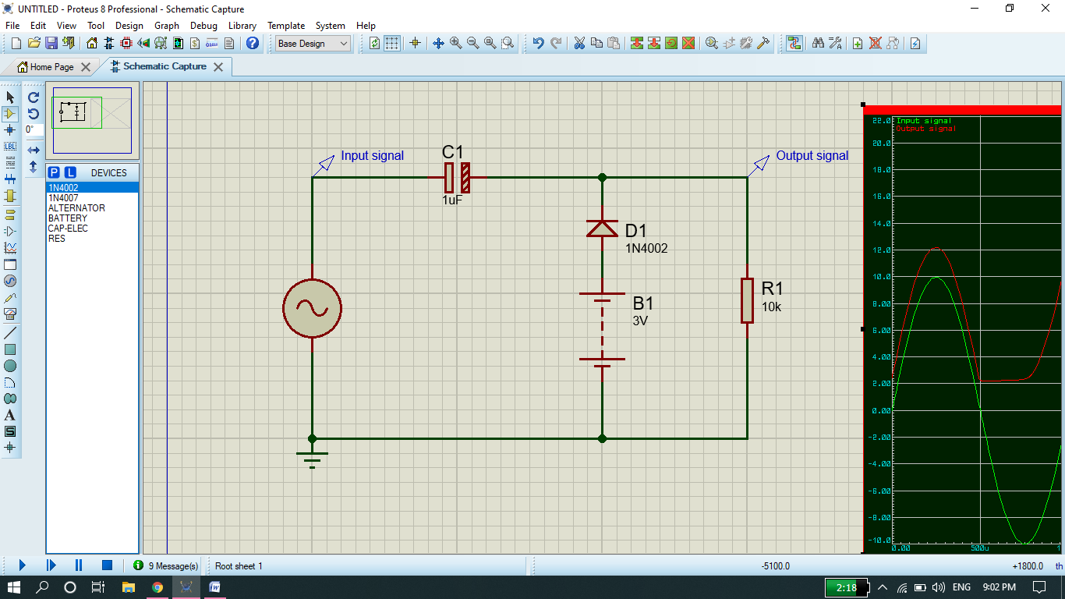

**Graph:**

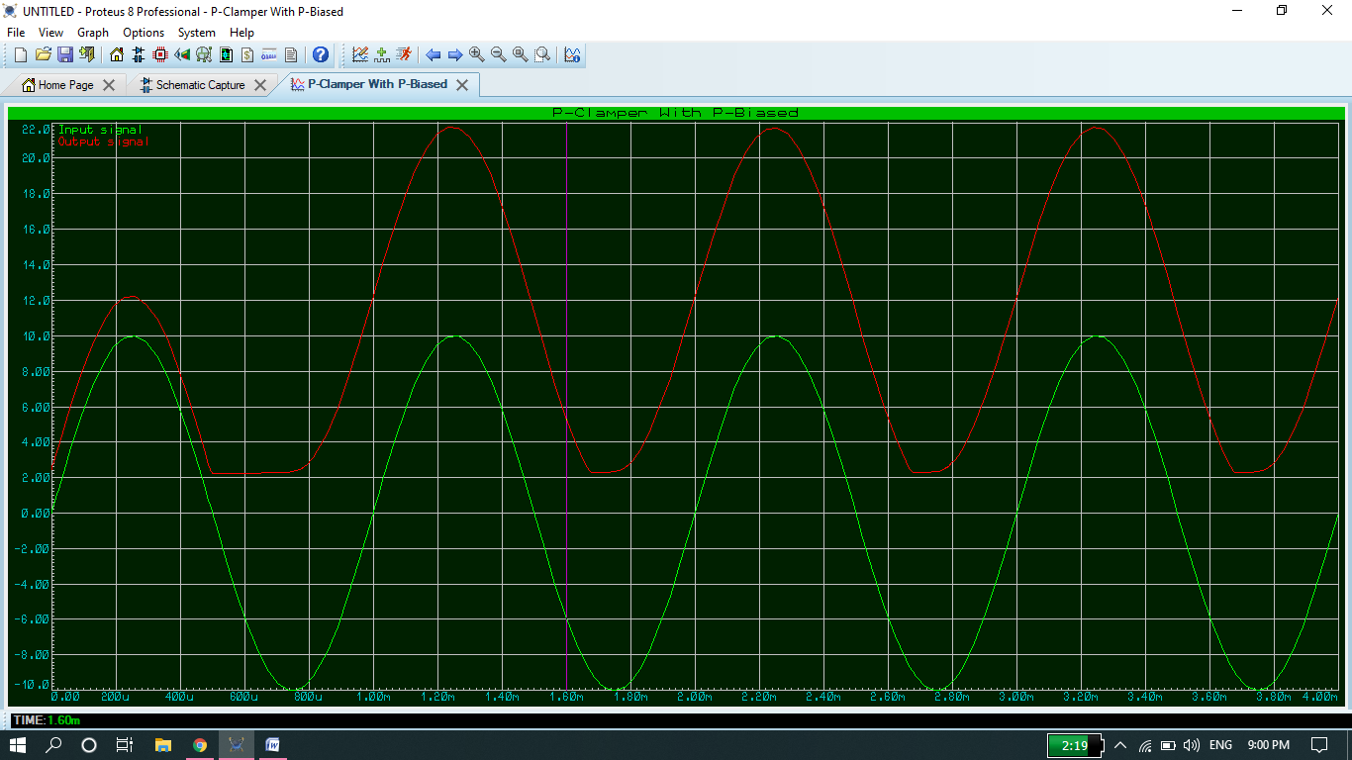

**NOTE: we can also verify the following Circuit 2 and 3 in proteus.**

### Positive clamper with negative bias:

**During positive half cycle:**

During the positive half cycle, the diode is reverse biased by both input supply voltage and the battery voltage. As a result, the signal appears at the output. The signal appeared at the output is equal to the sum of the input voltage and capacitor voltage.

**During negative half cycle:**

During the negative half cycle, the battery voltage reverse biases the diode when the input supply voltage is less than the battery voltage. As a result, the signal appears at the output.

When the input supply voltage becomes greater than the battery voltage, the diode is forward biased by the input supply voltage and hence allows electric current through it. This current will flows to the capacitor and charges it.

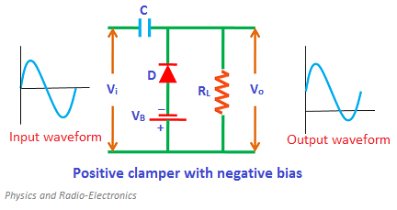

**Proteus Circuit:**

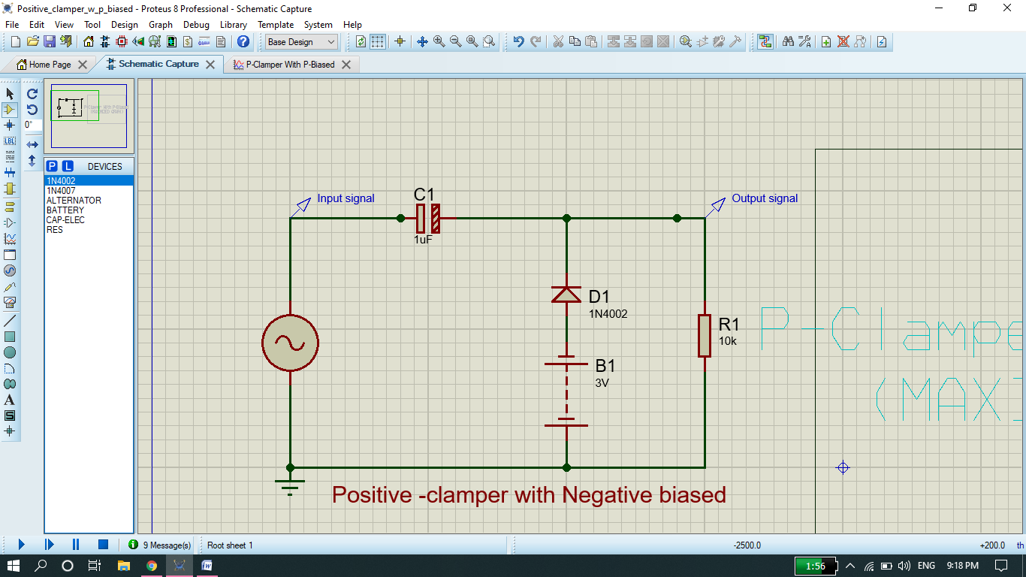

**Graph:**

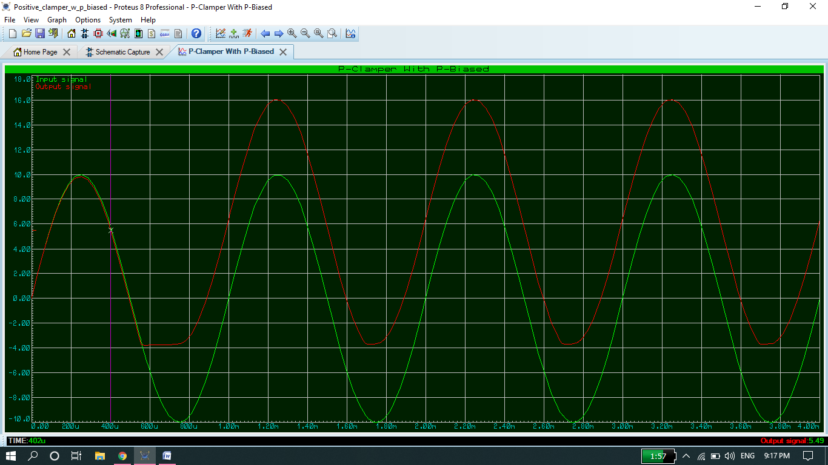

### Negative clamper with positive bias:

**During positive half cycle:**

During the positive half cycle, the battery voltage reverse biases the diode when the input supply voltage is less than the battery voltage. When the input supply voltage becomes greater than the battery voltage, the diode is forward biased by the input supply voltage and hence allows electric current through it. This current will flows to the capacitor and charges it.

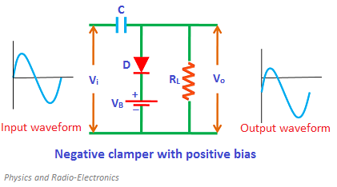

**During negative half cycle:**

During the negative half cycle, the diode is reverse biased by both input supply voltage and battery voltage. As a result, the signal appears at the output.

**Proteus Circuit:**

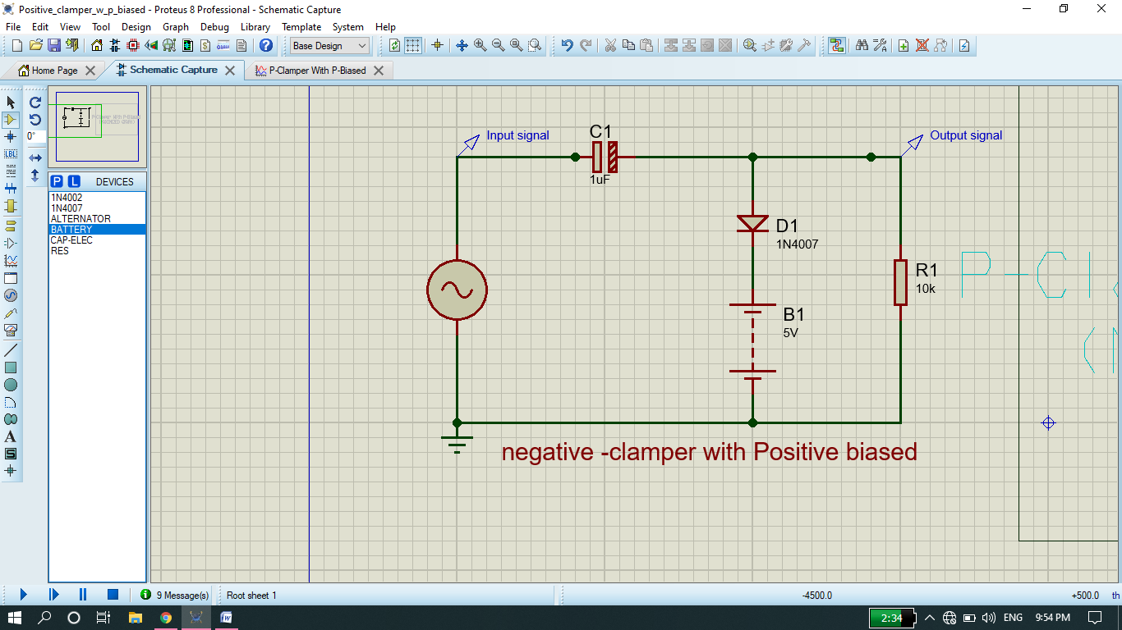

**Graph:**

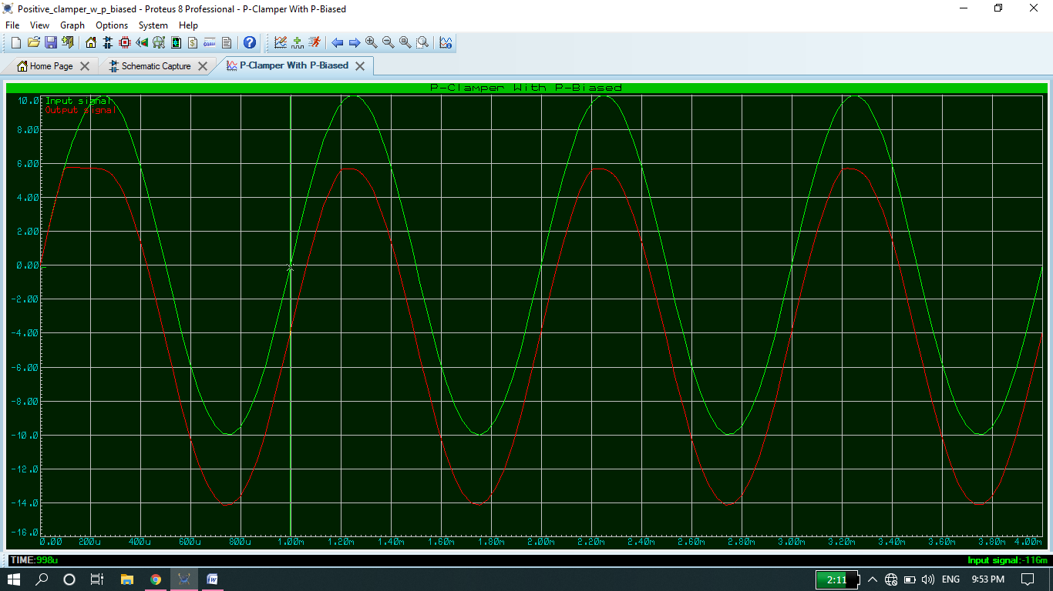

### Negative clamper with negative bias:

**During positive half cycle:**

During the positive half cycle, the diode is forward biased by both input supply voltage and battery voltage. As a result, current flows through the capacitor and charges it.

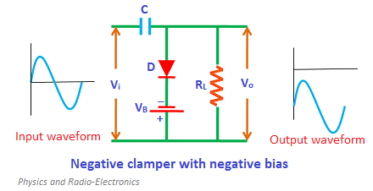

**During negative half cycle:**

During the negative half cycle, the battery voltage forward biases the diode when the input supply voltage is less than the battery voltage. When the input supply voltage becomes greater than the battery voltage, the diode is reverse biased by the input supply voltage and hence signal appears at the output.

**Proteus Schematic:**

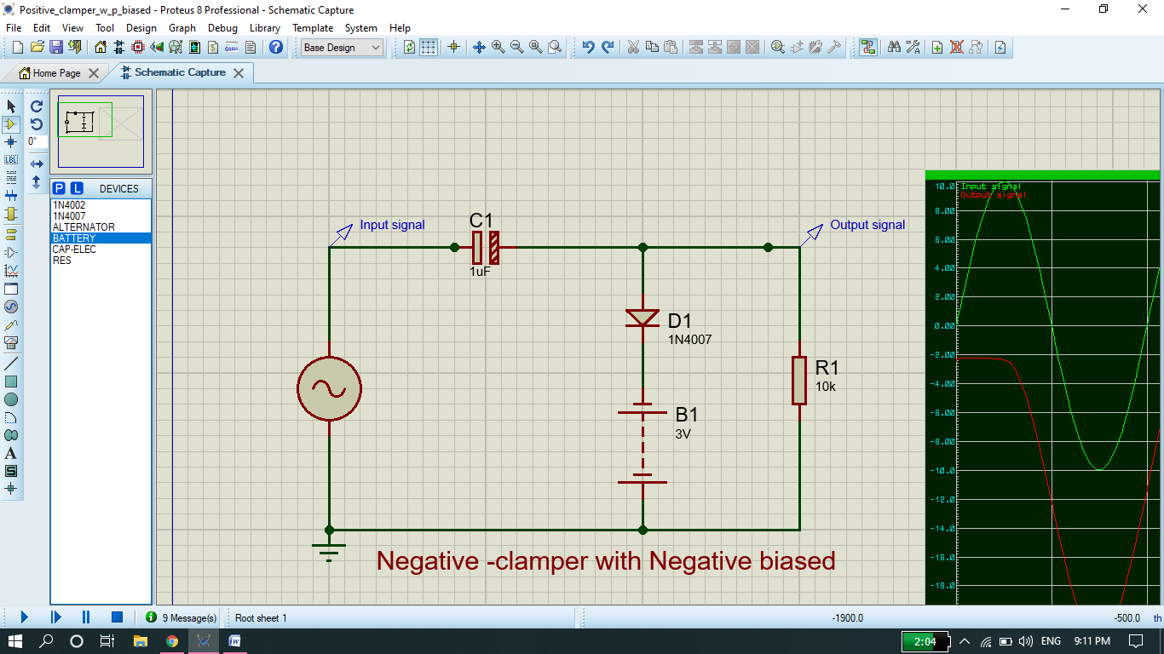

**Graph:**

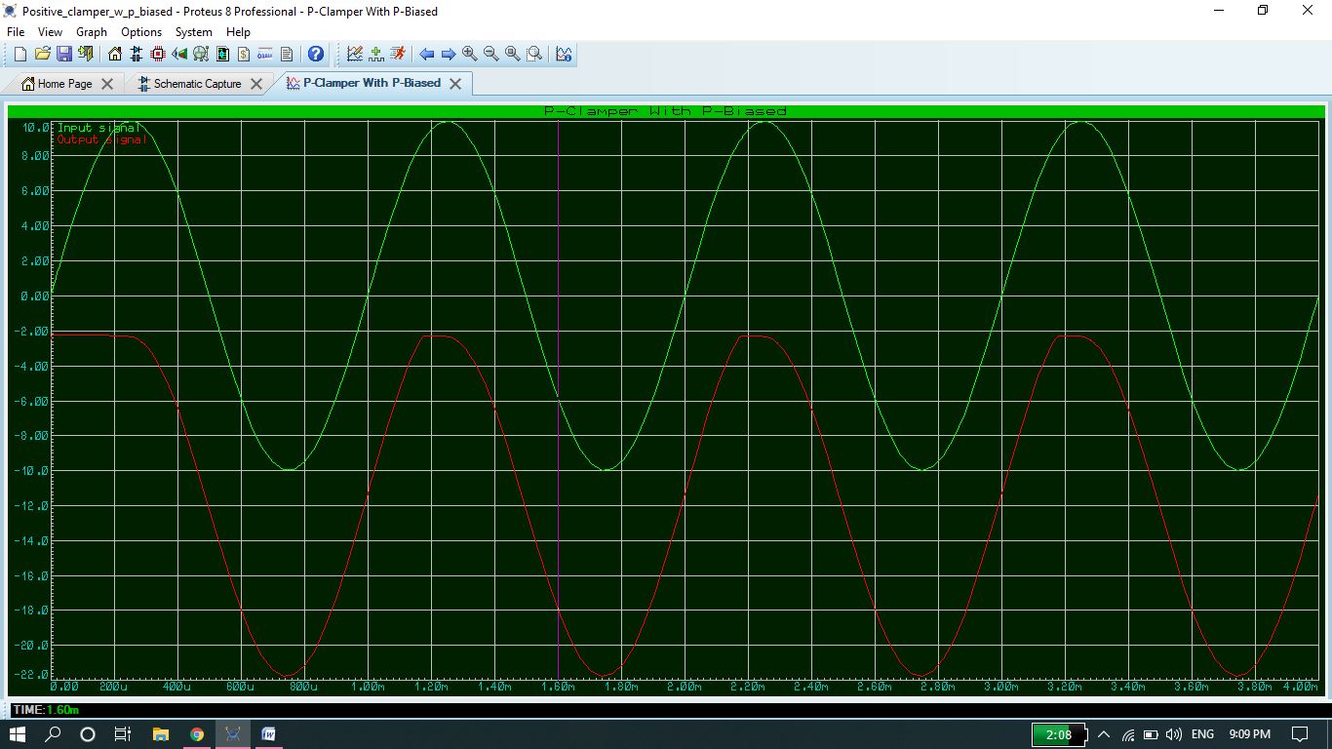

**Conclusion:**

1. Clampers can be used to increase the dc-value of the signal.
2. We connect a high value resistance in parallel with the diode to eliminate the distortion in the output signal.6.
3. A dc source can be connected in the clamper network to change the dc-level.

**The END**